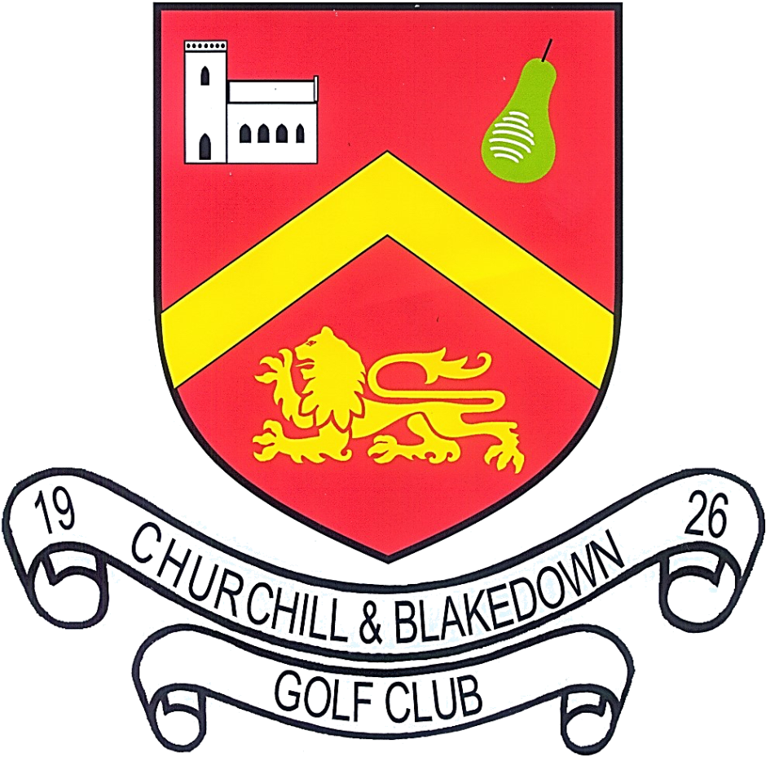
Friday 6th September 2024
Mixed Pairs Open
Mixed Pairs Betterball Stableford
85% of Course Handicap Allowance
Current Handicap Index required
Maximum allowed:-
Gents Index 28 and Ladies Index 36

Entry Fee
£20 per pair for Members, £40 per pair for Visitors and £30 per pair for combination

Contact Name |  |  |  | Phone No.
Address
Post Code
Email Address
Players Name |  | Club Name |  |  | HCP  Index |  |  | CDH Number
Start Times |  |  | 8:00– 09:50 |  |  |  | 12:30 – 14:30
Preferred Start Time (Please circle) |  |  | AM |  |  |  | PM

See over for payment methods and conditions
Please select payment method
Cheque(s) enclosed to the value of £……….. Made payable to: Churchill & Blakedown Golf Club
Card by telephoning Office 01562 700018 or Pro Shop 01562 700454
BACS to the value of £……… Reference – Quote 060924 Followed by your Contact Name & Initials
Bank Sort Code: 16-13-18
Bank Account Number: 10271520
Please post or email a copy of your entry form to:
Churchill & Blakedown Golf Club, Churchill Lane, Blakedown, DY10 3NB admin@churchillblakedowngolfclub.co.uk
Should you have any further enquiries please contact the pro shop: 01562 700454

We regret that we are unable to refund fees for withdrawals made after 31 July 2024
All prize winners will be advised by email
All entrants must be amateurs, aged over 18 years, members of a recognised golf
club and have returned a minimum of 5 acceptable scores for WHS handicap
purposes in the 12 months prior to the date of the event

